- Install Windows 2008 Server Standard.
- Check for updates.
- Added Role -- “Web Server (IIS)”

Configuring SQL Server 2008 Express

Install PowerShell using Server Manager
PowerShell is required for SQL Server Installation and for backup scripting functionality. To install it, do the following actions:
- Click on Start->Administrative Tools->Server Manager
- Select Features on the left-side panel
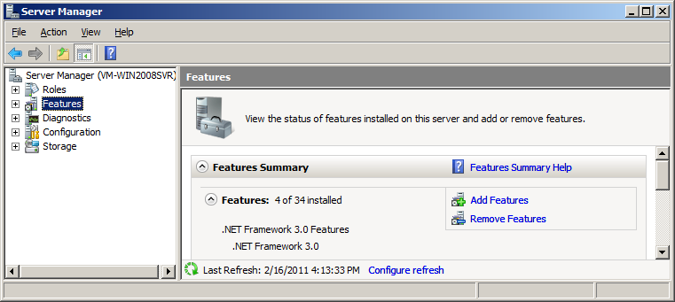
- Click on Add Features in the main panel.
- Select Windows PowerShell.
- Follow remaining instructions.
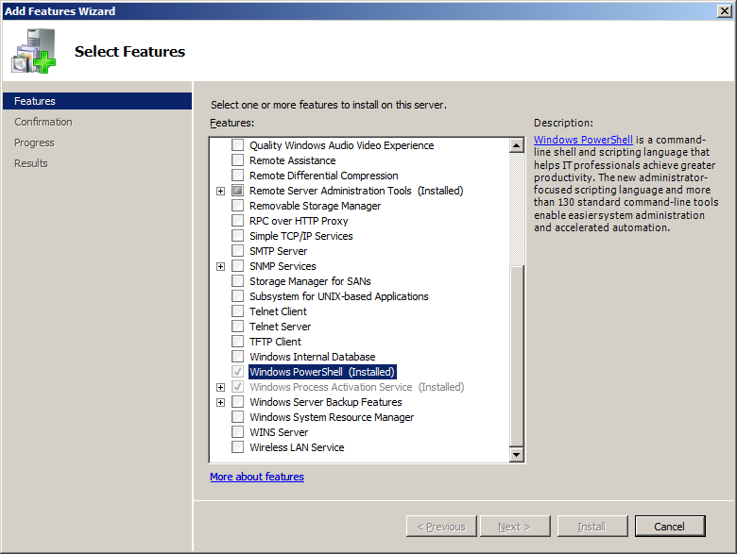

Install SQL Server 2008 Express using Microsoft installation package.
using “SQLEXPRWT_x86_ENU.exe”, acquired from the following URL:
http://www.microsoft.com/downloads/en/details.aspx?FamilyID=7522a683-4cb2-454e-b908-e805e9bd4e28
Instructions on installation can be found here:
http://www.microsoft.com/downloads/en/details.aspx?FamilyID=7522a683-4cb2-454e-b908-e805e9bd4e28#Instructions

